Pulling new file from the remote repo to the Local repo

**ANSWERS :**

1. Create a Working directory and add files to it

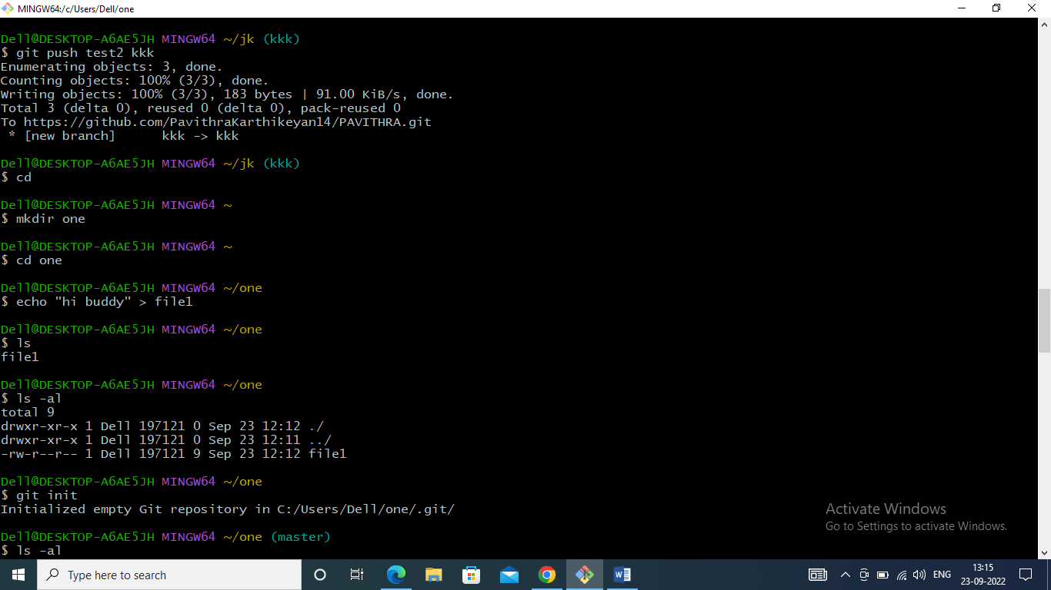

1. Initiate a git repository

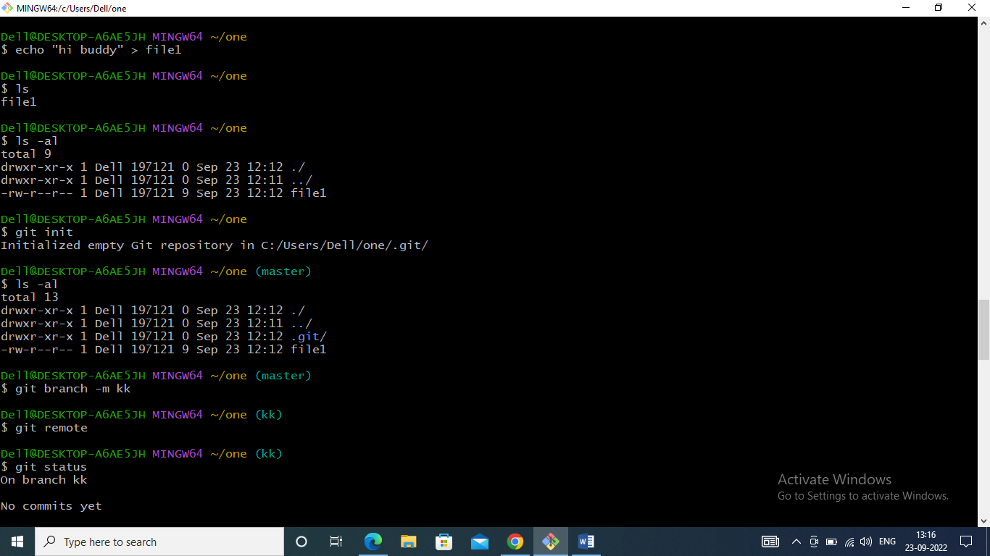

1. Add the files to the staging area

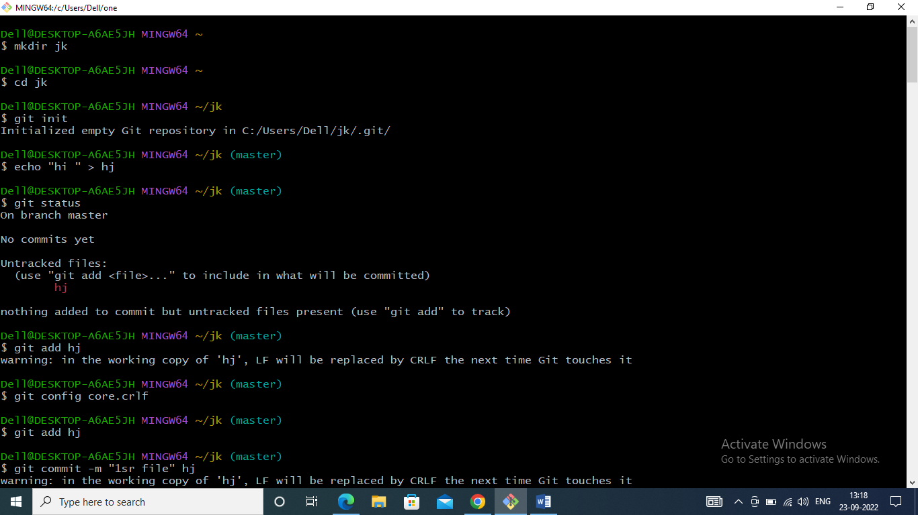

1. Commit the files to the local repository

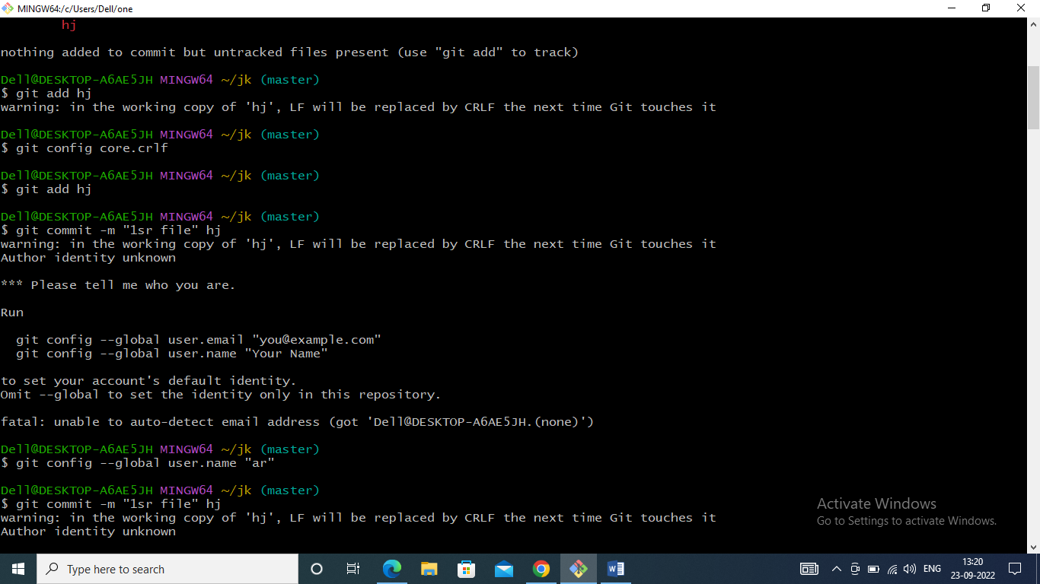

1. Create a new public remote repository

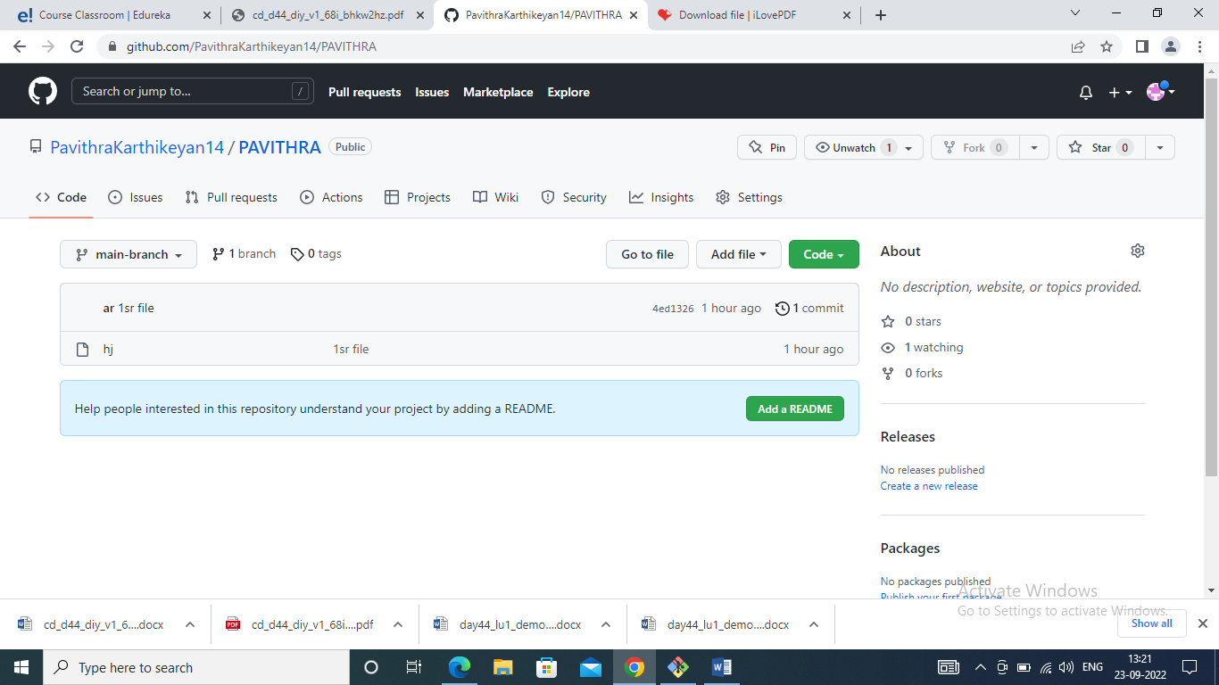

1. Add the remote repository path to the local repository

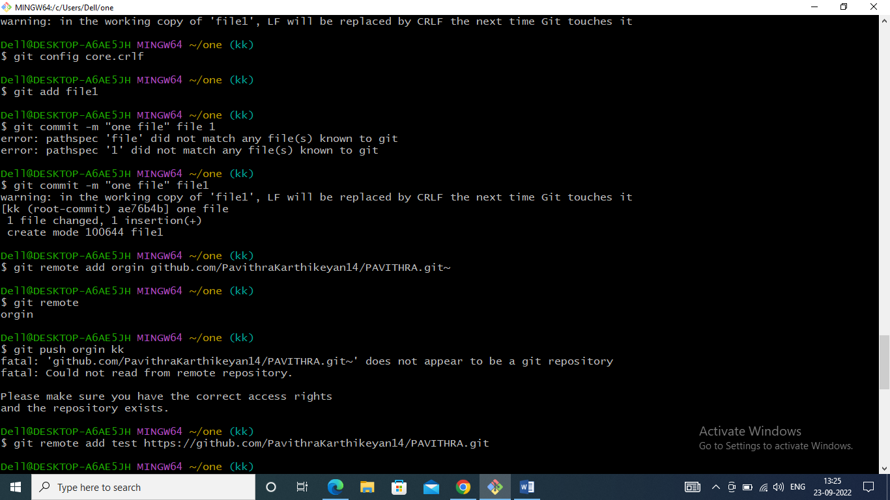

1. Set and check the remote variable

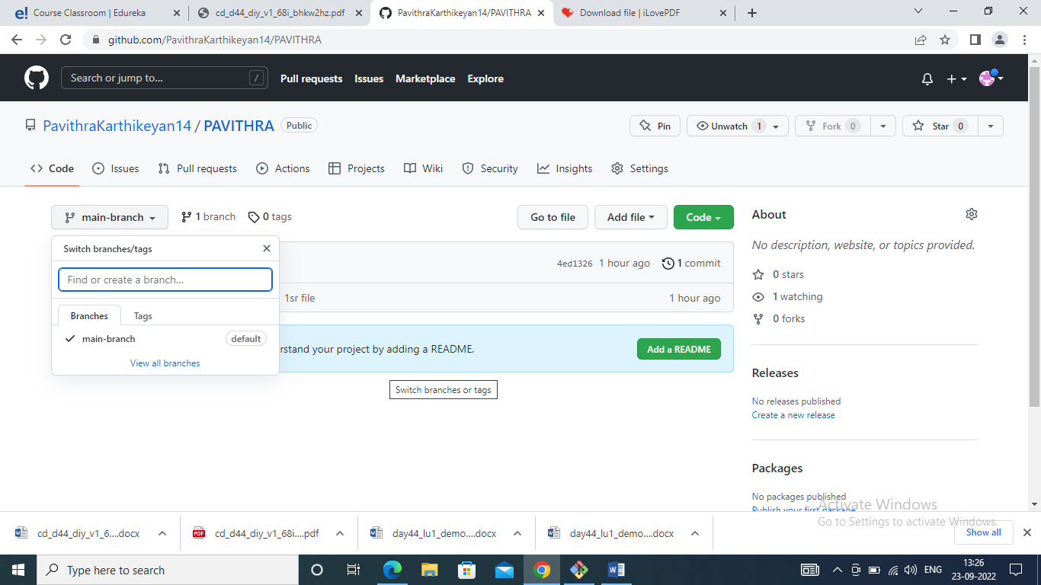

1. Push the files from the master branch to the remote repository

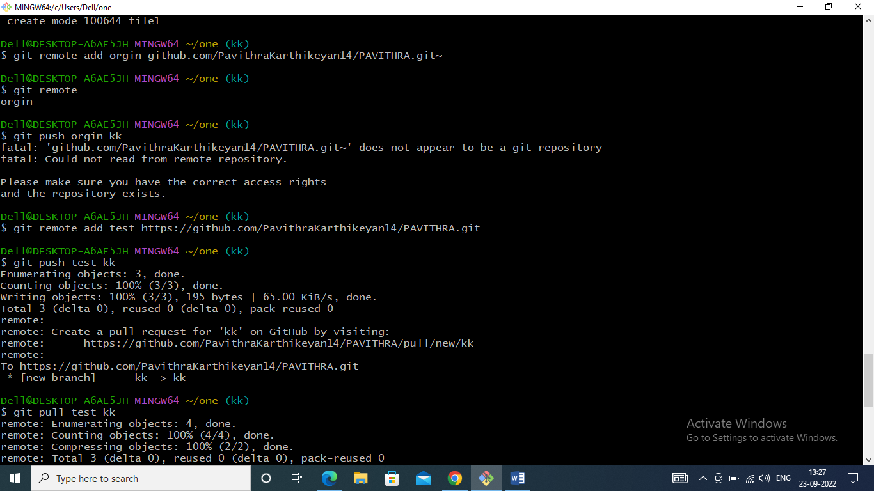

1. Add a new file in the remote repository.

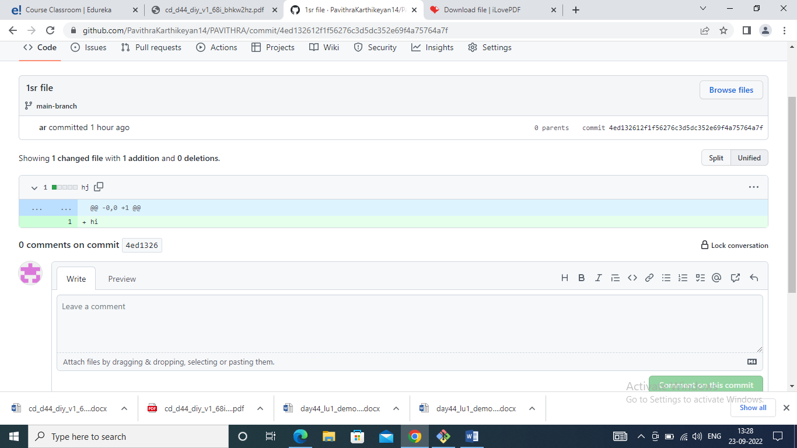

1. Pull the new file from the remote repo to the Local repo

